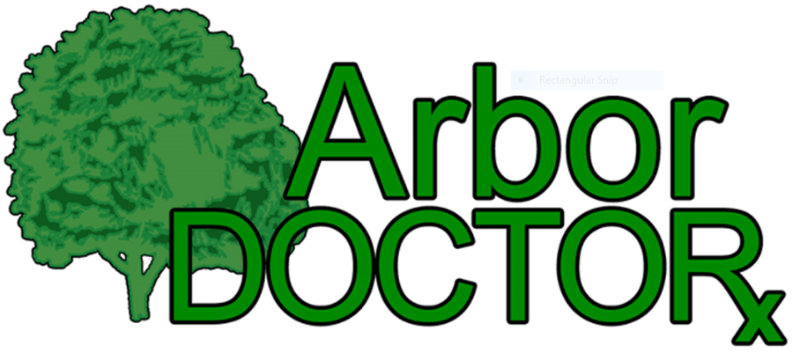
https://www.arbordoctor.com/

Arbor Doctor Summer 2026 Client Newsletter
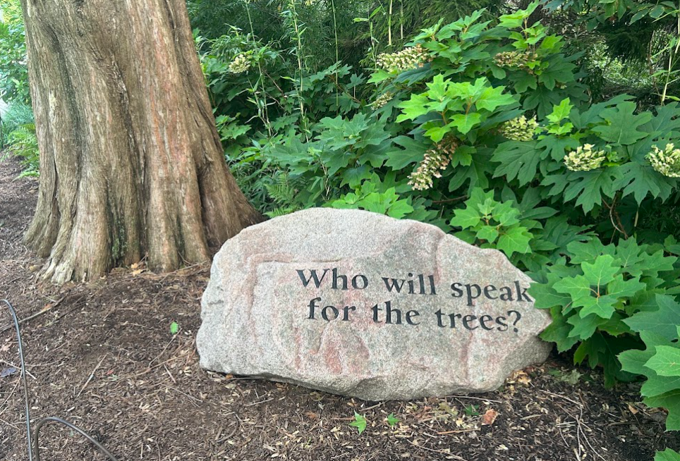
Can you believe that we are in the last month of meteorological summer already? Time sure does fly! I (Ron) am headed to Detroit for the annual international conference of the International Society of Arboriculture.
We continue to upgrade the professional credentials of our staff.
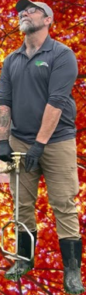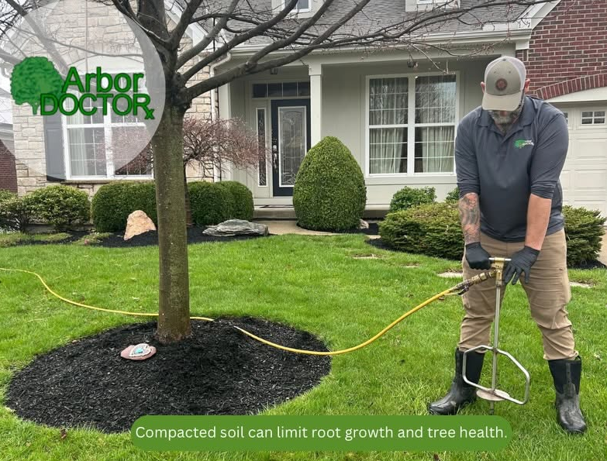
Team member David Deck is an ISA Certified Arborist and is qualified in tree risk assessment (TRAQ) and prescription pruning (PPQ), and has pesticide applicator licenses in Ohio, Kentucky, and Indiana.
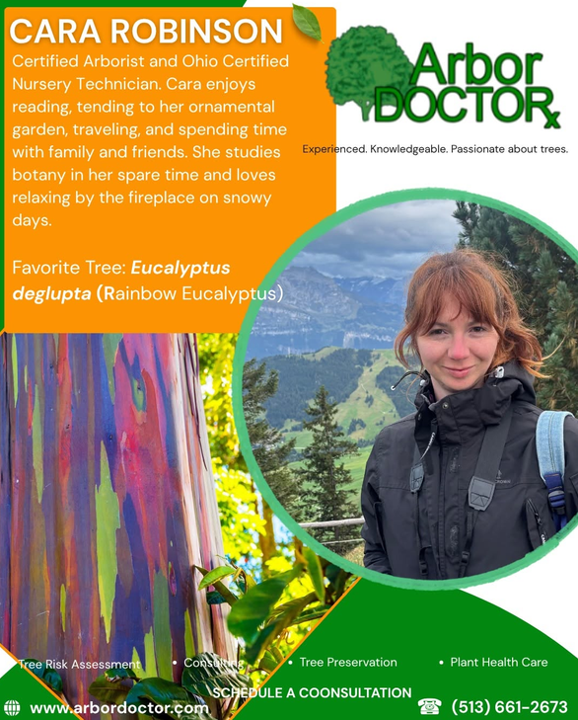
Team member Cara Robinson is an ISA Certified Arborist and Ohio Certified Nursery Technician. She holds multiple certifications, including, ODA and KY pesticide applicator licenses, RBGE Field Botany, Green Roof Design, and IUCN Red List Global Assessor. She has a Master’s degree in Plant Taxonomy and Biodiversity (granted distinction) from the University of Edinburgh. Her MSc research focused on the diversity and reproductive distribution of Cheilanthoid ferns in the Marañón Valley of Peru, a project that earned her the RBGE Award for research excellence. Cara has also worked in greenhouse crop production, digitization of herbarium collections, and conservation-oriented projects.
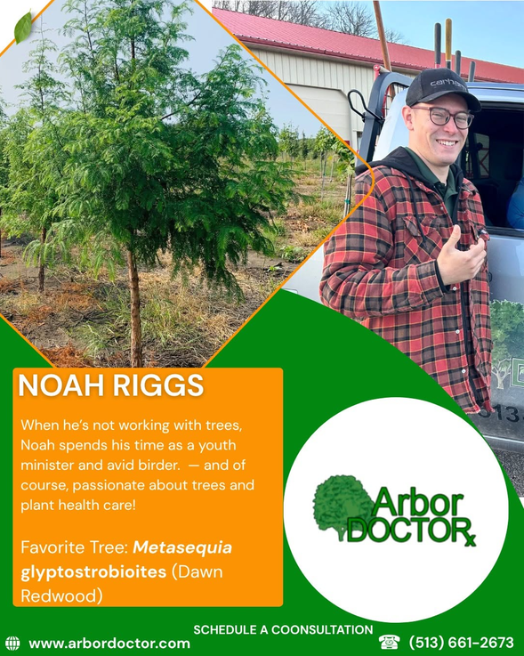

Team member Noah Riggs holds pesticide applicator licenses in Ohio, Kentucky, and Indiana.

Spread the word!

You can also go to this link>>>
When a Tree May Need Professional Evaluation
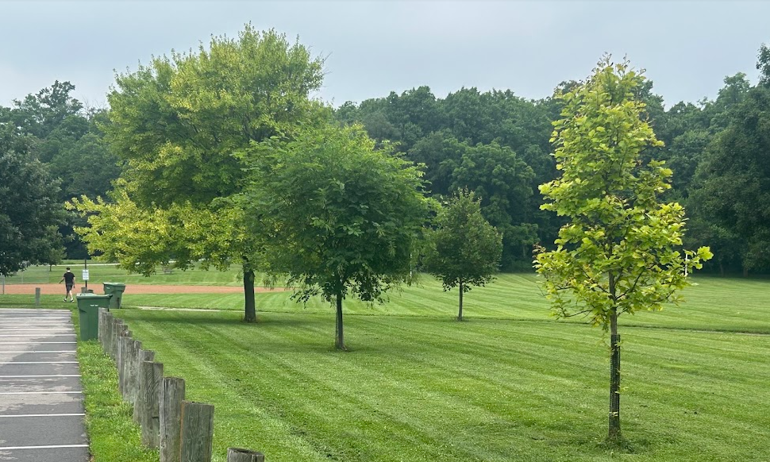
A professional tree evaluation is recommended whenever a homeowner observes symptoms that suggest declining health, impaired structure, root damage, decay, or recent change in the tree’s condition. This is especially important when the tree is located near a house, driveway, walkway, street, utility line, play area, patio, or other target where people or property could be affected if a branch or the entire tree fails.
Evaluation is particularly important after storms, construction activity, soil disturbance, trenching, grade changes, root injury, heavy pruning, lightning strikes, mechanical wounds, or any event that may have affected the trunk, scaffold limbs, or root system. Many serious defects are associated with wounds or root damage that allow decay fungi to enter and weaken wood over time.

Tree Risk Assessment: What It Is and When It Is Recommended
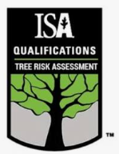
A tree risk assessment is a systematic evaluation of a tree’s likelihood of failure, the likelihood that a failed part would strike a target, and the probable consequences if that failure occurred. A risk assessment does not guarantee that a tree will or will not fail. Instead, it helps determine whether the level of risk is acceptable, whether risk can be reduced through pruning or other management, or whether removal should be considered.
A tree risk assessment is recommended when visible defects are present, when a tree has a history of limb failure, when decay indicators are observed, when a tree has developed a new or increasing lean, when roots appear damaged or unstable, or when a high-value tree stands in an area where failure could cause injury or significant property damage. It is also advisable before construction begins near mature trees and after severe weather events that may have damaged roots, limbs, or trunks. Because risk assessment requires specialized training, it is important to use an arborist who holds the ISA Tree Risk Assessment Qualification, commonly referred to as TRAQ, when a formal tree risk assessment is needed.
TRAQ-qualified arborists are trained in a standardized, systematic process for evaluating tree risk, including target assessment, site assessment, tree biology and mechanics, inspection methods, risk categorization, mitigation options, and reporting. This training helps the arborist make reasoned recommendations based on observed conditions rather than guesswork, fear, or a default assumption that removal is the only acceptable option.
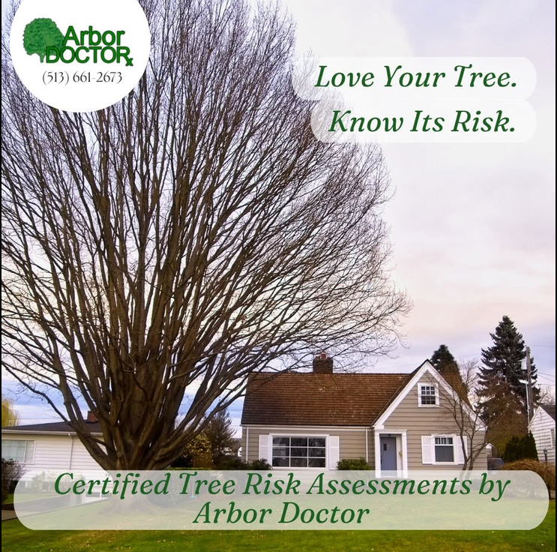

Why Credentials and Preservation Training Matter
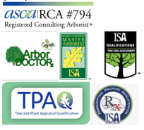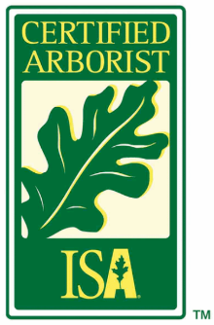
Homeowners should look for an ISA Certified Arborist, preferably one with substantial training and experience in tree health care, diagnosis, preservation, and risk assessment. Tree evaluation is not simply a question of whether a tree is alive or dead. A knowledgeable arborist must consider species characteristics, site conditions, soil limitations, root health, pest and disease pressure, structural defects, decay indicators, past pruning, construction impacts, and the tree’s potential to respond to treatment or management.
This distinction matters because not everyone who advertises tree services has the training needed to evaluate tree health, structural integrity, or preservation options. Some individuals may refer to themselves as arborists even though they are not certified, do not maintain professional credentials, and may not have sufficient knowledge of tree biology, pathology, wood decay, soil science, pruning standards, or risk assessment. In addition, some tree service providers have a financial incentive to recommend removal because removal work can be more profitable than diagnosis, monitoring, soil improvement, pruning, or preservation-based care.
For that reason, homeowners should ask about credentials, relevant training, and experience before relying on an opinion that a tree must be removed. When a tree has significant value, provides important shade, contributes to the landscape, or has defects that are not clearly understood, an assessment by an ISA Certified Arborist with TRAQ qualification and preservation-oriented experience can help distinguish between reasonable risk reduction, health care options, monitoring, and removal when removal is truly warranted.

Why Fungal Conks on Trees Should Never Be Ignored
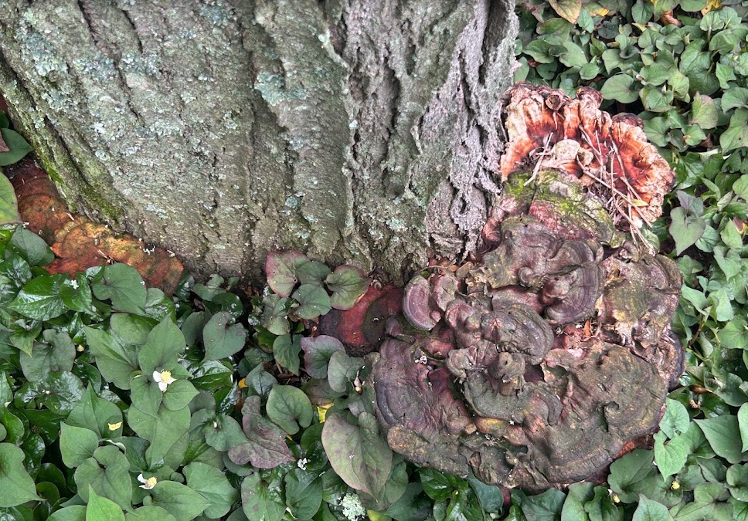
Fungal conks, mushrooms, brackets, or shelf-like growths attached to the trunk, root flare, buttress roots, major limbs, or exposed roots should never be dismissed as merely cosmetic. These structures are the fruiting bodies of fungi, and many wood-decay fungi produce visible conks only after they have been active inside the tree for an extended period. The presence of a conk does not automatically mean that a tree must be removed, but it does mean the tree deserves careful inspection.
Decay fungi can reduce the strength of wood in trunks, roots, and limbs. In some cases, the tree may still have a full green canopy while internal wood or roots are losing structural integrity. This is why a tree can appear vigorous and still present a risk of limb failure or whole-tree failure. Conks at the base or root flare are especially important because decay in that area may affect the tree’s anchorage and load-bearing support.

The Importance of Early Detection
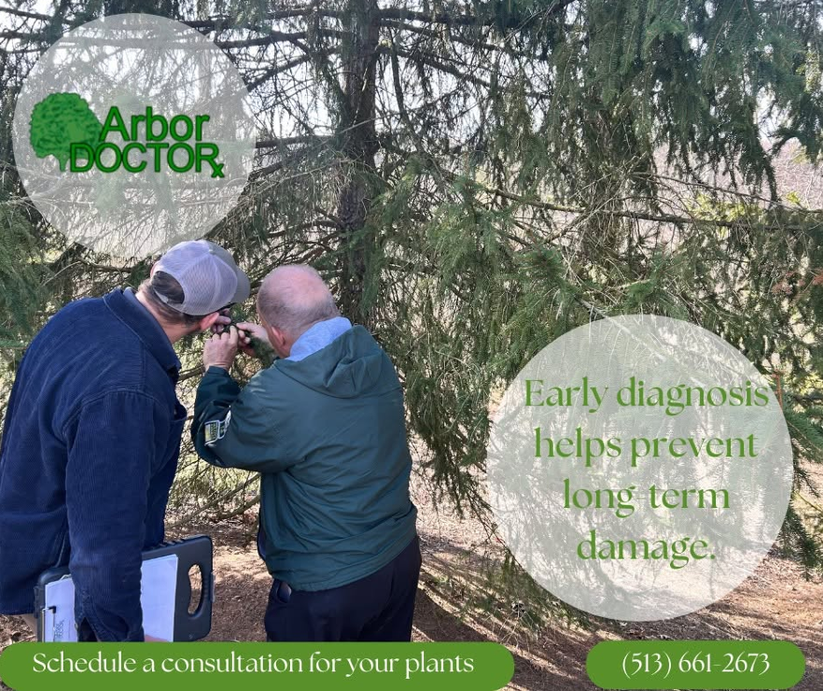
Early detection gives homeowners and arborists more options. When decline, decay, pest activity, root injury, or structural defects are identified early, it may be possible to reduce stress, improve growing conditions, prune defective limbs, limit target exposure, monitor the tree more closely, or make informed decisions before the situation becomes urgent. Waiting until symptoms become obvious often means the underlying problem has already progressed.
Many trees decline gradually. A thinning canopy, reduced twig growth, premature fall color, smaller leaves, branch dieback, or excessive production of seeds or cones may indicate that the tree has been under stress for years. By the time large limbs die, fungal fruiting bodies appear, bark separates, or the tree begins leaning, corrective options may be limited and risk may be higher.

Common Signs of Tree Decline
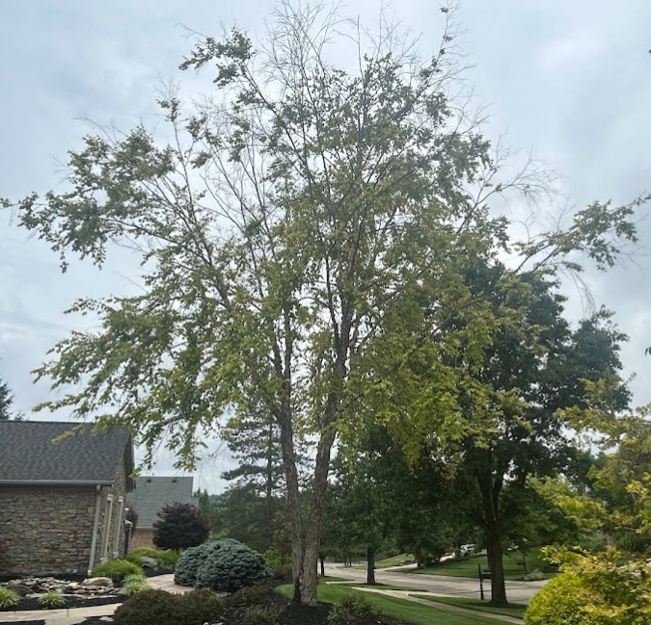
- Thinning canopy, sparse foliage, or smaller-than-normal leaves during the growing season.
- Dead branches, especially large dead limbs or dieback concentrated in the upper crown.
- Premature fall color, early leaf drop, delayed spring leaf-out, or leaves that wilt without obvious drought explanation.
- Fungal conks, mushrooms, brackets, or shelf-like growths attached to the trunk, root flare, buttress roots, or major limbs.
- Cracks, seams, cavities, hollow-sounding areas, loose bark, or areas of soft, punky, crumbly wood.
- New or increasing lean, soil heaving, raised roots, cracked soil near the root flare, or exposed roots that appear damaged or decayed.
- Large pruning wounds, storm wounds, lightning scars, mower damage, construction injury, or other openings where decay may enter.
- Frequent shedding of dead twigs, larger branch failures, or broken limbs hanging in the canopy.
- Evidence of boring insects, woodpecker activity concentrated in one area, carpenter ant activity, or sawdust-like frass near the trunk or base.
- Changes that are new, worsening, or different from previous years, especially when several symptoms occur together.

When to Call a Qualified Arborist Promptly
Call a qualified arborist promptly if a tree has fungal conks attached to the trunk or root flare, a new or worsening lean, soil heaving, large dead limbs, hanging broken branches, major cracks, visible cavities, extensive crown dieback, or symptoms that have changed noticeably since the previous season. Keep people, pets, vehicles, and movable property away from areas beneath large dead limbs or trees that appear unstable until the tree has been evaluated.
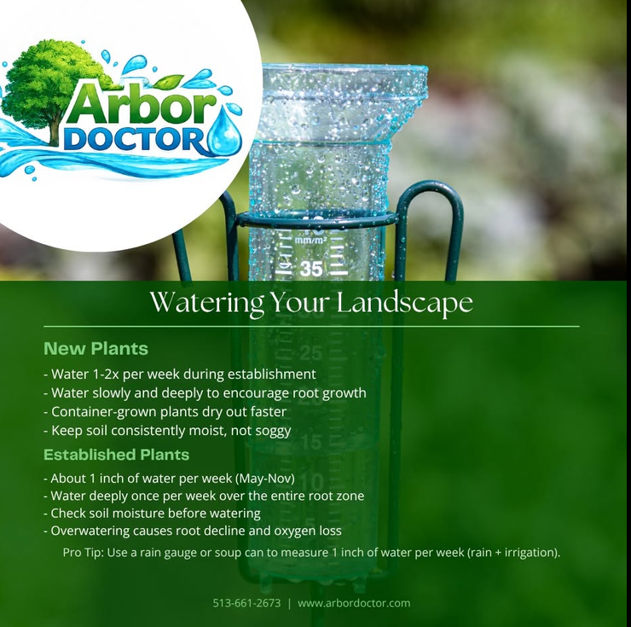

Additional recent blog articles:
Using Tree of Heaven as a Trap Tree for Spotted Lanternfly
Queen Ann’s Lace vs. Poison Hemlock. What’s the difference?
Mimosa Webworms on Honeylocust
Solitary Oak Leafminer: An Oddity or a Serious Pest?
Grass-Carrying Wasps Moving In?
Lace Bug Litany
Tree removal is over-represented in social media
August 2, 2026 Soil Moisture, Condition Monitoring and Drought Update
July 2026 Weather and Climate Summary


Hydrocephalus. A cause that’s very personal…

Ron with Friday Keynote Speaker Danny Bonaduce (aka Danny Partridge from the 1970’s TV show The Partridge Family). Bonaduce was diagnosed with adult onset, Normal Pressure Hydrocephalus several years ago.
In July, I attended the National Conference on Hydrocephalus. This was a medical conference for physicians, researchers, and patients. It had nothing to do with horticulture, but a lot to do with me. You see, I was born with congenital hydrocephalus, so I have lived with the condition for 61 years. I have had three brain surgeries. I have daily discomfort and fairly frequent headaches.
For decades I didn't know anybody else who had the condition. Then the Internet came along, and I found hydrocephalus groups. Then I found the Hydrocephalus Association. This is the first time I have attended the conference. I got to meet other people who have been dealing with the disease and doctors and researchers who are working on better treatments and even cures.
Hydrocephalus is one of the most serious and common conditions that you may never have heard of. It is statistically as common as Parkinson's disease. There are people with hydrocephalus who have had 200 brain surgeries. I am very blessed that I have only had three. The condition is not curable. The shunt, which corrects the problem, has one of the highest failure rates of any implanted medical device. Few improvements have been made in the shunt since its invention in the 1950s.
Hydrocephalus is commonly misdiagnosed as Alzheimer’s Disease, Dementia, or Parkinson’s Disease, which is unfortunate because, if correctly diagnosed, the condition is generally correctable. One study indicated fewer than 20% of physicians could correctly diagnose Hydrocephalus if presented with its symptoms.
Keynote speaker Danny Bonaduce (aka Danny Partridge of the Partridge family TV show in the 1970s ) was diagnosed with the condition several years ago and now has a shunt implanted. Billy Joel was diagnosed with the condition several years ago. When I was born in 1964, nobody had lived with this condition past middle age. It was still thought that I would die young. I am part of the first generation living into old age with hydrocephalus. There is no track record to draw on. We are pioneers on this journey.


I will be participating in the Cincinnati Walk to End Hydrocephalus on Saturday, September 26, 2026.
Please donate to my page to find a cure for Hydrocephalus. Click here>>>


Please feel free to call our office if you would like assistance with planting or scheduling a service.
Sincerely yours,
Ron Rothhaas and The Arbor Doctor Team

https://www.arbordoctor.com/

