


Dearest Clients,
As we head toward the traditional Memorial Day kick off to summer (and meteorological summer), we’re excited to share a few updates from Arbor Doctor LLC along with important reminders to help keep your landscape healthy and thriving.
. Please leave us a Google Review at Arbor Doctor LLC!
We are pleased to welcome two new team members: Cara who holds a master’s degree in plant Taxonomy & Biodiversity from the University of Edinburgh, Scotland, with a strong background in horticulture as well as her Ohio Certified Nursery Technician License, and Allyson, who has a bachelor’s degree in Botany and lots of experience in horticulture. Their knowledge and passion for plant health care will be a great asset to our clients and community.
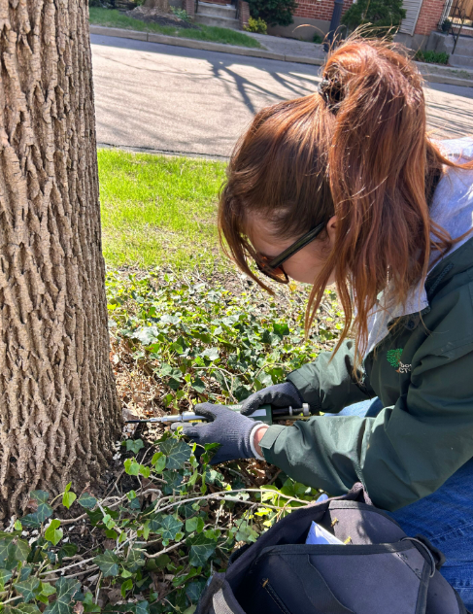
We are also proud to announce that both Matt and Cara have achieved Certified Arborist status. This certification reflects a high level of expertise and commitment to proper tree care and industry standards, and we congratulate them on this accomplishment. They joined Arbor Doctor team member Dave Deck, who is also an ISA Certified Arborist and recently achieved the ISA Tree Risk Assessment Qualification and the Prescription Pruning Qualification.
Figure 1. Cara doing an EAB injection on an ash tree.

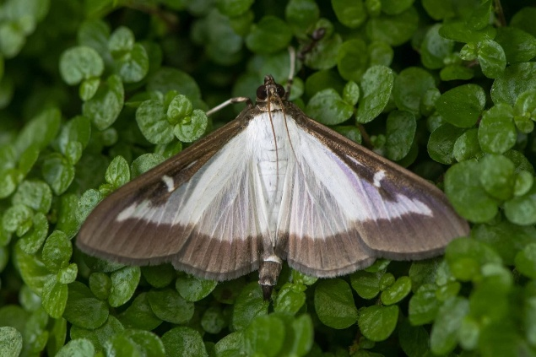
As we move into spring, it is important to stay alert for emerging pest pressures in our region. The Box Tree Moth can cause significant damage to boxwoods, often showing up as browning foliage, thinning plants, interior dieback, or visible chewing and webbing. If you notice any of these symptoms, please contact our office right away to ensure your landscape is properly monitored and included in a treatment program.
Figure 2. Box tree moth adult stage and caterpillar stage.
We also continue to track the spread of the Spotted Lanternfly, which can be identified by egg masses on hard surfaces, early-stage black and white nymphs, and later red and gray adult insects. While this species feeds on a variety of woody and ornamental plants, its preferred host plant is the tree of heaven, Ailanthus altissima. This association is ecologically significant, as A. altissima populations often support higher SLF densities and facilitate local population establishment. Early detection is key to reducing impact.
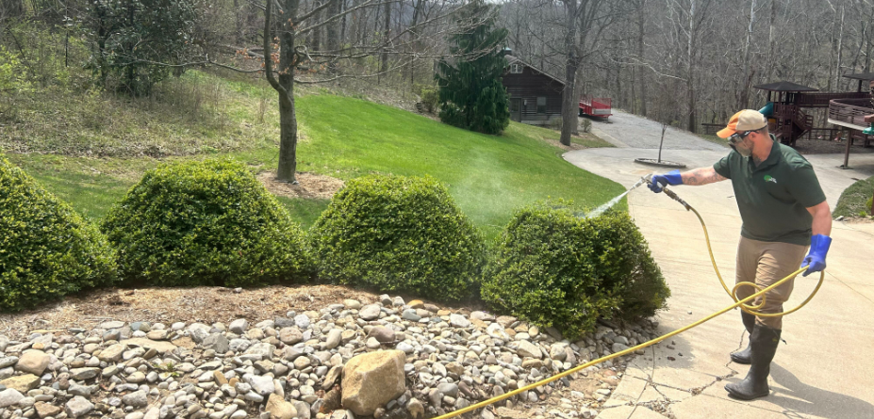
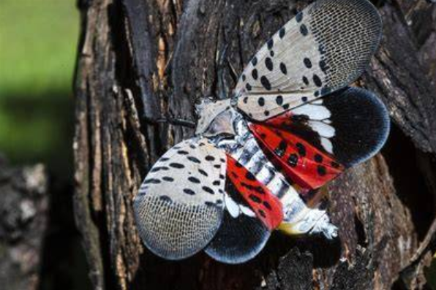
We’d like to remind you as we approach warmer weather, proper watering is one of the most important factors in maintaining healthy landscapes. For most established trees, shrubs,
perennials, and lawns, we recommend watering once per week with a total of about one inch of water from May through November, including rainfall. Water should be applied under the entire branch spread, and you should avoid irrigating if the soil is already moist. A simple way to measure this is by using a straight-sided can or rain gauge in your yard, since local rainfall varies and your plants respond only to what falls on your property.
Figure 4. Our very own Dave, Certified Arborist following a targeted treatment program on Boxwoods for Box Tree Moth.
Figure 3. Spotted Lantern Fly Adult Stage

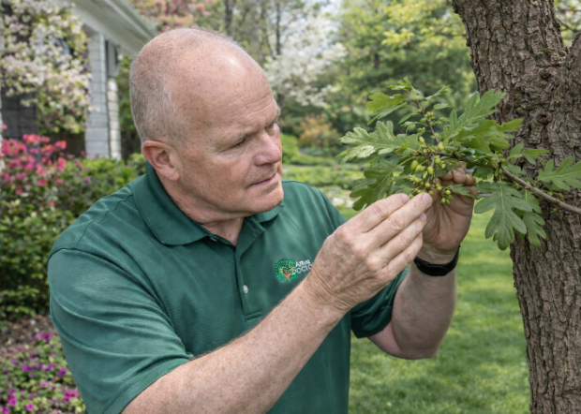
For newly planted trees and shrubs, extra care is needed during establishment. The root ball should be thoroughly watered once or twice per week, while also checking soil moisture to avoid overwatering, which can cause stress or decline. Container-grown plants are especially sensitive to drying out during the first couple of years after planting. Spring is also an excellent time for planting trees and shrubs, and our team is available to help with proper installation or selecting the right plant for your site.
Figure 4. Ron, Certified Master Arborist and owner of Arbor Doctor, inspecting the health of a mature oak tree.

Can I prune my neighbor’s tree if it grows over my yard?
In Ohio, you have the legal right to trim overhanging tree branches and roots up to your exact property line. However, Ohio common law and statutes place strict limitations on how you exercise this right to prevent property damage and legal liability.
1. The Right to Clear Airspace
- Trimming Boundary: You can clear encroaching branches or roots, but your cuts must stop precisely at the vertical property boundary line.
- No Trespassing: You cannot step onto your neighbor’s land, scale their side of the tree, or reach over the property line to cut without their explicit permission.
2. The Duty of "Reasonable Care"
- Tree Health: According to legal guidance from the Ohio State University Extension and Ohio State Bar Association, you must use reasonable care when pruning.
- Prohibited Harm: You cannot trim the branches so aggressively that you compromise the overall health of the tree, cause disease, compromise its stability, or kill it.
3. Severe Penalties for Reckless Damage
If your trimming recklessly severely injures or kills the neighbor's tree, you can face severe legal consequences under Ohio Revised Code and state timber laws: Treble Damages: In a civil lawsuit, a court can order you to pay three times the replacement value of the damaged tree to your neighbor.
- Criminal Liability: Recklessly injuring someone else's tree without permission is classified as a fourth-degree misdemeanor in Ohio, carrying potential fines up to $250 and up to 30 days in jail.
4. Ownership Exceptions
- Trunk Location: Ownership is determined strictly by where the trunk meets the ground. If the trunk rests entirely on your neighbor's side, it is their tree.
- Boundary Line Trees: If the trunk physically straddles the property line, the tree is considered commonly owned property. Neither neighbor may remove or cut it in a way that harms the tree without mutual agreement.
Recommendation: Because you are liable if the tree dies, it is best practice to notify your neighbor before cutting, or hire a certified arborist to ensure the cuts will not kill the tree. This article is derived from several sources but should not be considered legal advice. For that, consult at attorney.

From the Arbor Doctor blog and Arbor Doctor Weather Ready Nation Weather Blog…
Why Are My Trees Wilting?
Parking Lot Trees…. Killing them one Tree at a Time!
Thunderstorms conjure ghostly coronae in treetops, observed outdoors for the first time
Who’s been chewing on my plants?
Nearly 200-year-old Tri-State tree could be threatened by nearby highway project. Arbor Doctor called in
The Tree Disease and Decline Spiral
𝐓𝐫𝐞𝐞𝐬 𝐃𝐨𝐧'𝐭 𝐍𝐞𝐠𝐨𝐭𝐢𝐚𝐭𝐞: 𝐓𝐡𝐞 𝐓𝐫𝐚𝐧𝐬𝐩𝐥𝐚𝐧𝐭 𝐅𝐚𝐧𝐭𝐚𝐬𝐲
January 2026 Regional Weather Summary
Weather Summary - February 2026
March 2026 Weather Summary
Regional Weather Summary - April 2026

If you were happy with our service, would you mind taking a minute to leave us a Google review? Your feedback not only helps our small business grow, but it also helps other homeowners feel confident choosing Arbor Doctor.
You can simply:
• Click the link below
Click here to leave us a review
or

• Scan the QR code
Memorial Day 2026

We are approaching Memorial Day which is the traditional kick off of summer and, ironically, it corresponds almost perfectly with the beginning of meteorological and climatological summer.
Memorial Day is a federal holiday in the United States dedicated to honoring and mourning the military personnel who died while serving in the U.S. Armed Forces.
Origins and History
- Civil War Roots: The holiday originated in the late 1860s following the American Civil War, which claimed more lives than any prior U.S. conflict.
- Decoration Day: It was originally called Decoration Day because citizens would decorate the graves of fallen soldiers with flowers, wreaths, and flags.
- Waterloo, New York: In 1966, the federal government officially declared Waterloo, New York, as the birthplace of the holiday for hosting the first formal, community-wide observance in 1866.
- General John A. Logan: In 1868, this Union veteran leader officially proclaimed Decoration Day, choosing May 30 because flowers would be in full bloom across the nation.
Evolution to a National Holiday
- World War I Pivot: The holiday originally only honored those killed in the Civil War. It evolved after World War I to honor all American service members who died in any war.
- Name Change: The name gradually shifted from Decoration Day to Memorial Day over the 20th century.
- Uniform Monday Holiday Act: Congress passed this act in 1968, moving the holiday from May 30 to the last Monday in May to create a three-day weekend. The change took effect nationwide in 1971.
Traditions and Observances
- National Moment of Remembrance: Americans are encouraged to pause for one minute of silence at 3:00 PM local time.
- Flag Protocol: The U.S. flag is briskly raised to the top of the staff, then solemnly lowered to half-staff until noon, before being raised to full-staff for the rest of the day.
- Grave Decorations: Volunteers and families place small American flags on graves at national cemeteries, including Arlington National Cemetery in Washington, DC, and Spring Grove Cemetery and Arboretum in Cincinnati.
- The Arlington Memorial Gardens in Cincinnati, Ohio, is hosting its 11th Annual Field of Memories celebration from Friday, May 22 through Monday, May 25, 2026. Located in Springfield Township, the cemetery transforms its grounds with a massive display of 1,000 American flags visible from Ronald Reagan Highway.
Daily Exhibits & Visitation Hours
- Hours: The grounds are open to the public daily from 9:00 AM to 7:00 PM all weekend long.
- Flag Display: Walk through 1,000 distinct 3'x5' flags mounted on 6' poles, each honoring active military, veterans, first responders, or public servants.
- Special Exhibits: The historic "Eyes of Freedom & Silent Battle" military memorial exhibit and the 9/11 Steel display will be open on-site throughout the weekend.
Special Weekend Events
- Flowers of Remembrance Day (Sunday, May 24): A dedicated remembrance ceremony featuring patriotic displays and tributes.
- Lunch with a Veteran (Sunday, May 24 @ 11:30 AM): A complimentary community lunch hosted at the Garden of Patriotism to honor and support local veterans.
- Team Fastrax Skydiving Jump (Sunday, May 24 @ 12:30 PM): A live, patriotic parachute jump landing directly into the Field of Memories area.
- Flag Raising Ceremony (Sunday, May 24 @ 1:00 PM): Co-hosted alongside American Legion Post 513.
- National Moment of Remembrance (Monday, May 25 @ 3:00 PM): A nationwide minute of silence, followed immediately by a traditional musket salute from the Sons of the American Revolution and the reading of the 2026 flag dedication names.
Flag Dedications & Charity
Members of the public can purchase and dedicate a flag on the Arlington Memorial Gardens Event Page to honor a loved one. All net proceeds from the 2026 flag sponsorships directly benefit Operation Ramp It Up, a non-profit building wheelchair accessibility ramps for disabled veterans.

Have a blessed Memorial Day, and to those of you who have served or have loved ones who have served, thank you and God Bless You.
Please feel free to call our office if you would like assistance with planting or scheduling a service.
Sincerely yours,
The Arbor Doctor Team

